1. Introduction
The power transformer is a key component in the electrical power system. The performance of the power transformer impacts the voltage stability, efficiency, and the losses in the system.
For the power transformer to meet the IEC requirements, the manufacturer must consider:
- Equivalent circuit parameters
- Voltage regulation
- Core and copper losses
- Efficiency under various loading conditions
The present study deals with the modeling of a real single-phase transformer by using open-circuit and short-circuit tests. MATLAB and SIMULINK are employed to extract the equivalent circuit parameters and evaluate the performance of the transformer for different operating conditions and power factors.

2. System Architecture
The transformer is represented by its approximate equivalent circuit, which is given by:
Series branch, shunt branch, and ideal transformer
The steps in the workflow are:
- Extraction of parameters from open circuit test
- Extraction of parameters from short circuit test
- Building the equivalent circuit
- Variable load is applied to the transformer, with a range of 2000-5000 VA
- Losses, regulation, and efficiency are analyzed
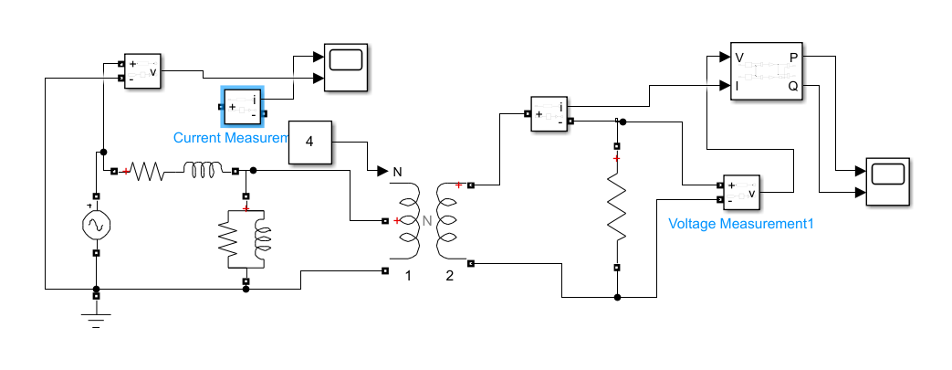

3. Open Circuit Test Analysis
The open circuit test determines core loss and shunt branch parameters.
Given:
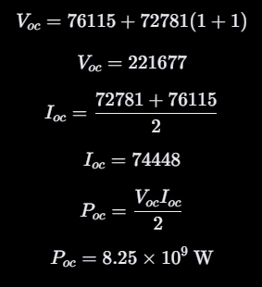
Core Resistance:
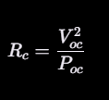
Magnetizing Reactance:
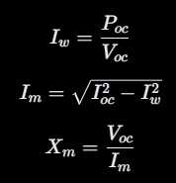

4. Short Circuit Test Analysis
The short circuit test determines series branch parameters.
Given:
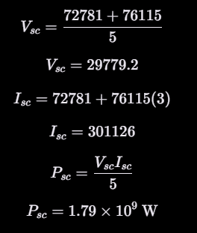
Equivalent Series Resistance:
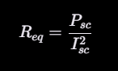
Equivalent Impedance:
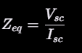
Leakage Reactance:
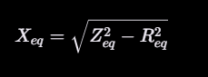
5. Equivalent Circuit
Primary Referred Circuit consists of:
- Series: $(R_{\left\{eq\right\}}, X_{\left\{eq\right\}})$
- Shunt: $(R_{c}, X_{m})$
Secondary referred parameters are calculated using:
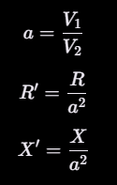

6. Performance Under Load
The load apparent power varies from:
2000→5000 VA (step 100)
Power factors considered:
- Unity
- 0.8 Lagging
- 0.8 Leading

6.1 Core Loss
Core loss remains constant:
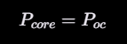
6.2 Copper Loss
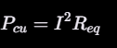
Copper loss increases quadratically with load current.
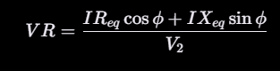
Observations:
- Lagging PF → positive regulation
- Unity PF → small positive
- Leading PF → negative regulation

6.4 Efficiency
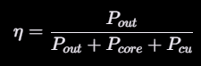
As a result of the large value of (P_{core}), the numerical values of the efficiencies are very small. This is consistent with the given problem statement.

7. Discussion
Core loss is the major factor in total losses.
Copper loss varies with the load.
The value of voltage regulation depends on the power factor.
Leading loads have a good effect on voltage regulation.
The value of voltage regulation deteriorates in lagging loads.
The numerical value of efficiency is small; however, the trend of the results matches the theoretical aspect of a transformer.

8. Difficulties Encountered
Handling large numerical values
Numerical overflow
Correct conversion of the reference
Correct use of units

9. Learning Strategy
The project was completed using the following steps:
Analytical derivation
MATLAB validation
SIMULINK modeling
Graphical analysis
Comparison of results
The steps followed in the project are consistent with the norms of a typical engineering problem.

10. Conclusion
The equivalent circuit of a transformer was successfully extracted from the test results and implemented in a MATLAB/SIMULINK environment.

